Submitted By: Aiman Ismail

Task 2: Data Visualization
Class distribution graph:
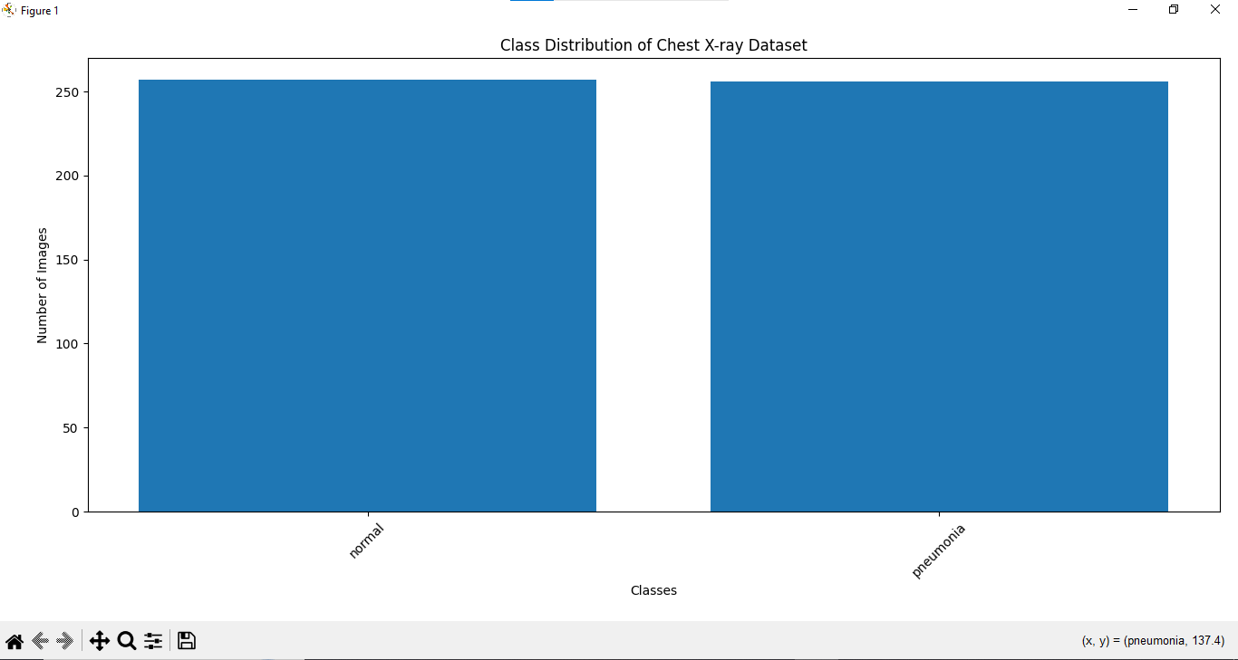
Sample image visualization:
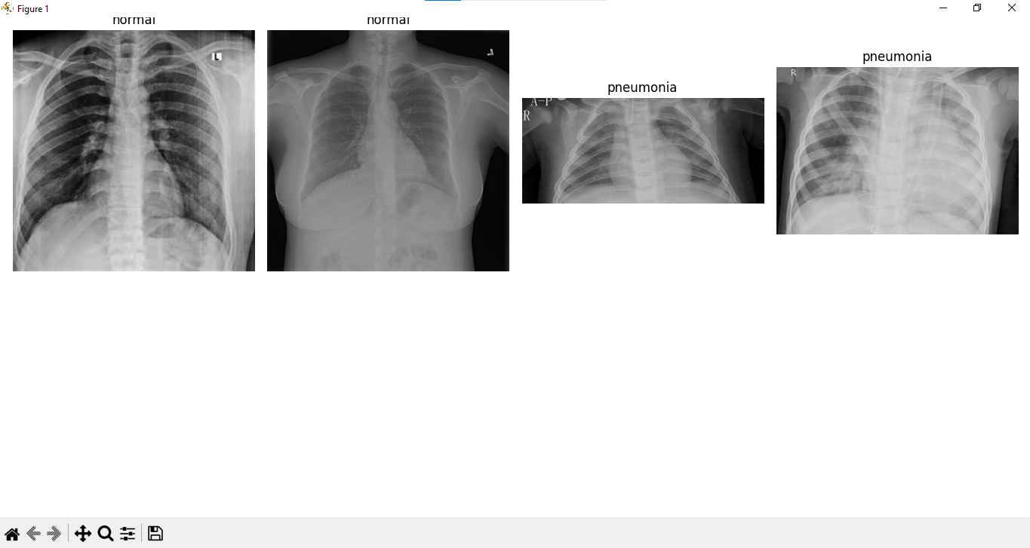

Image dimension summary:
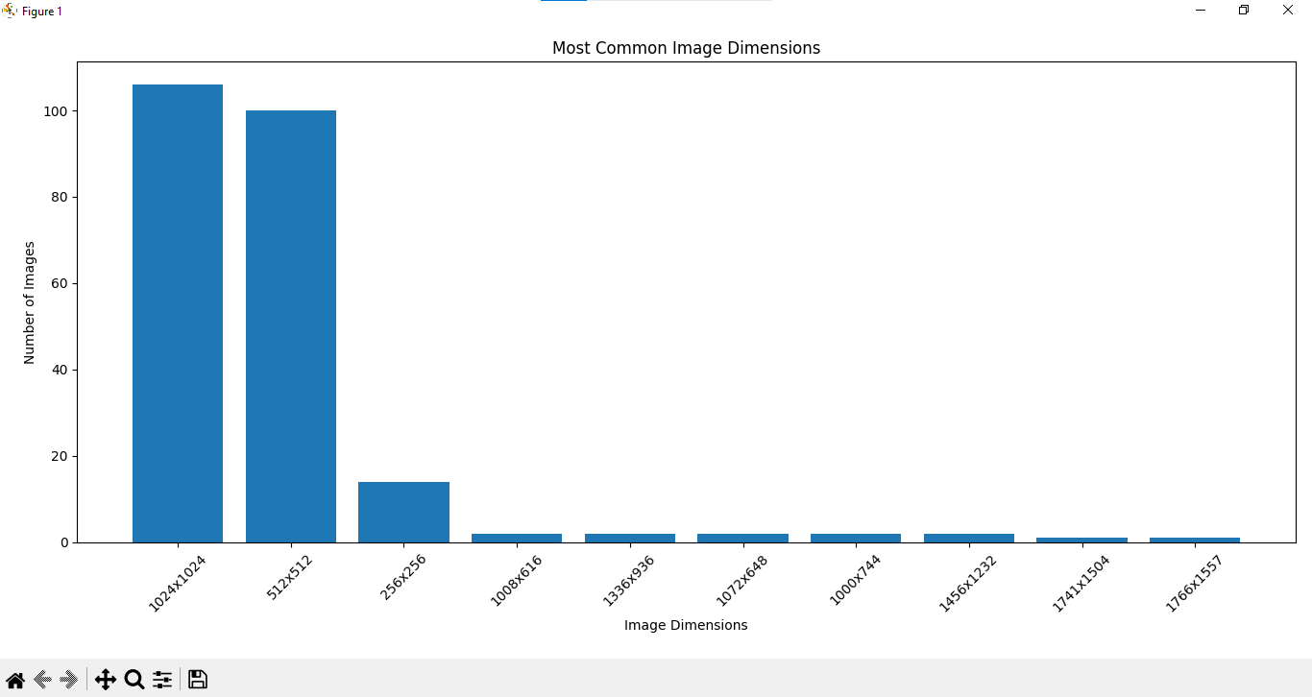

Task 3: Experimental Design

Training/validation/testing split.
Dataset will be divided into three parts.

1. Training Set: 70%
This data is used to teach the CNN model.
For example, if we have 10,000 images:
7,000 images → Training
The model looks at these images and learns patterns such as:
- Shapes
- Textures
- Brightness patterns
- Abnormal regions in X-rays

2. Validation Set — 15%
This data is used to check the model while training.
For example:
1,500 images → Validation
The model does not use these images directly to learn.
Instead, they help us check whether the model is improving or making mistakes during training.

3. Testing Set — 15%
This data is used only at the end.
For example:
1,500 images → Testing
The model has never seen these images during training.
Therefore, the testing set gives us a better idea of how the model performs on data.

Image input size (224 × 224).
Original images may have different sizes.
For example:
- 1024 × 1024
- 640 × 480
- 512 × 512

But a CNN needs images of the same size. Therefore, before giving an image to the CNN, every image will be resized to:
224 × 224 pixels

Example:
Original Image
1024 × 1024
↓
Resize
↓
224 × 224
↓
CNN Model
This makes sure that every image has the same dimensions when entering the model.
If the images are grayscale, the input may be:
224 × 224 × 1
If convert them to RGB, the input becomes:
224 × 224 × 3
For chest X-rays, grayscale input with 1 channel is usually natural.

Initial CNN architecture:
The initial CNN architecture is the first model design for test. CNN stands for:
Convolutional Neural Network
It is commonly used for image classification. A simple CNN can be:
Input Image
224 × 224
↓
Convolutional Layer
↓
ReLU Activation
↓
Max Pooling
↓
Convolutional Layer
↓
ReLU Activation
↓
Max Pooling
↓
Convolutional Layer
↓
ReLU Activation
↓
Max Pooling
↓
Flatten
↓
Dense Layer
↓
Output Layer

1. Input Layer
Receives the image:
224 × 224

2. Convolutional Layer
This layer looks for important patterns in the X-ray.
At the beginning, it may detect:
- Edges
- Lines
- Basic shapes
Deeper layers can learn more complex patterns.

3. ReLU Activation
ReLU helps the network learn complex patterns. We do not need to understand its mathematical formula deeply for the experimental design. ReLU helps the CNN learn non-linear patterns.

4. Max Pooling
Max pooling reduces the size of the data while keeping important information.
For example:
Large feature map
↓
Smaller feature map
This makes the model:
- Faster
- Less computationally expensive

5. Flatten Layer
CNN layers produce feature maps. The Flatten layer converts those feature maps into a single long list of numbers.
Example:
Feature Maps
↓
Flatten
↓
One long vector

6. Dense Layer
The Dense layer uses the learned information to make a decision.

7. Output Layer
The output depends on the number of classes.
For example, if dataset has:
- Normal
- Pneumonia
- Tuberculosis
then the model needs to predict one of these three classes.

Accuracy
Accuracy is the percentage of total predictions that are correct. In simple words, accuracy tells us:
Out of all the predictions made by the model, how many were correct?
For example, suppose a model makes predictions for 100 samples. If it correctly classifies 90 samples and incorrectly classifies 10 samples, its accuracy is 90%.
Accuracy provides a general overview of the model's performance. However, it may not always give a complete picture when the classes in a dataset are imbalanced. For example, if one class contains significantly more samples than another, a model may achieve high accuracy simply by predicting the majority class most of the time.

Precision
Precision measures how many of the samples predicted as a particular positive class were actually positive. Precision answers:
When the model predicts a positive result, how often is that prediction correct?
For example, suppose the model predicts that 100 samples belong to a particular class. After comparing these predictions with the actual labels, 85 samples are found to actually belong to that class. In this case, the precision is 85%.
A high precision means that the model produces fewer false positive predictions. In other words, when the model predicts that something belongs to a particular class, the prediction is more likely to be correct.

Recall
Recall measures how many of the actual positive samples were correctly identified by the model.
In simple words:
Out of all the samples that actually belong to a particular class, how many did the model correctly identify?
For example, suppose there are 100 samples that actually belong to a particular class. If the model correctly identifies 90 of them, then the recall is 90%.
A high recall means that the model is good at finding actual positive cases. A low recall means that the model is missing a larger number of samples that actually belong to the class. These missed cases are known as false negatives.

F1-score
F1-score is a metric that combines precision and recall into a single score.
In simple words, the F1-score tells us:
How well does the model balance making correct positive predictions and identifying all actual positive samples?
For example, a model may have:
- Precision = 90%
- Recall = 80%
The F1-score combines these two values to provide a balanced measurement of the model's performance.
F1-score is especially useful when the dataset contains imbalanced classes, meaning that some classes have significantly more samples than others. In such situations, accuracy alone may be misleading, while the F1-score provides a better understanding of the balance between precision and recall.

Task 4: Related Work Table

No. | Study | Dataset | CNN Model | Explainability Method | Reported Accuracy / Performance | Limitations
1 | An Explainable Transfer Learning Framework for Multi-classification of lung diseases in Chest X-rays (2024) | A comprehensive lung X-ray dataset covering COVID-19, pneumonia, tuberculosis, and pulmonary lung nodules. | EfficientNet-B4 with transfer learning from a pretrained model. | Grad-CAM, used to visualize salient features and activation regions influencing the classification decision. | The proposed system achieved 96% accuracy for multi-disease classification. | The study emphasizes the need for continued development of transparent diagnostic models. Broader validation using more diverse and independent datasets would be important to establish generalization beyond the evaluated dataset.
2 | Explanatory Classification of CXR Images into COVID-19, Pneumonia and Tuberculosis Using Deep Learning and XAI (2022) | 7,132 CXR images from three publicly available datasets: 576 COVID-19, 4,273 pneumonia, 700 TB, and 1,583 normal images. | A proposed lightweight single CNN model for four-class classification. Images were resized to 180 × 180 × 3. | Grad-CAM, LIME, and SHAP. The explanations were further assessed with medical expertise. | Training accuracy: 95.76 ± 1.15%; validation accuracy: 94.54 ± 1.33%; test accuracy: 94.31 ± 1.01% using 10-fold cross-validation. | The dataset was class-imbalanced, particularly for COVID-19 and TB. The study also notes challenges related to the computational cost of large pretrained models and the need to make model decisions understandable.
3 | Explainable Lung Disease Classification from Chest X-ray Images Utilizing Deep Learning and XAI (2024) | 10,095 chest X-ray images classified into five categories: viral pneumonia, bacterial pneumonia, COVID-19, tuberculosis, and normal. | Multiple models were evaluated, including Xception, InceptionV3, VGG19, EfficientNetB7, DenseNet201, DenseNet121, and ResNet50, along with hybrid, ensemble, transformer, and Big Transfer approaches. | LIME and Grad-CAM. LIME provides local explanations for individual predictions, while Grad-CAM generates heatmaps highlighting image regions that contribute to the model's classification decision. | Fine-tuned Xception achieved 96.21% accuracy using 5-fold cross-validation. | The use of data collected from different sources can introduce dataset variation and potential bias. The findings require validation on independent clinical datasets to confirm generalization.
4 | Multi-Scale CNN: An Explainable AI-Integrated Unique Deep Learning Framework for Lung-Affected Disease Classification (2023) | Multiple datasets were evaluated. One reported four-class experiment used Bacterial Pneumonia, COVID-19, Fibrosis, and Normal classes. | Proposed Multi-Scale CNN (MS-CNN) architecture designed to extract features at multiple scales. | The paper integrates Explainable AI methods to interpret model predictions and identify influential features and regions. | For the reported four-class experiment, the proposed model achieved 99.21% testing accuracy with a testing loss of 0.0498. | The study evaluates multiple datasets and disease combinations, making dataset composition and distribution important when comparing results. Further testing on independent datasets is needed to determine how well the architecture generalizes.
5 | An Explainable AI-Enabled Framework for Interpreting Pulmonary Diseases from Chest Radiographs (2023) | The study uses COVID-CT and COVID-NET resources. The dataset table lists 800 images and 2 classes for COVID-CT, and 19,000 images and 3 classes for COVID-NET. The proposed model comparison reports 787 CT scans and 10,000 CXR scans. | The study evaluates DenseNet169, MobileNet, COVID LargeNet, and a proposed CNN-based model. | LIME was used in the proposed XAI system to provide interpretable explanations of predictions. | The proposed model reported 93% accuracy for the COVID-CT component and 97% accuracy for the COVID-NET/CXR component. | The study primarily focuses on COVID-19 versus non-COVID-19 classification, rather than broad multi-disease classification. The use of different datasets and imaging sources also limits direct comparison between results.
6 | Toward Explainable AI in Radiology: Ensemble-CAM for Effective Thoracic Disease Localization in Chest X-ray Images Using Weakly Supervised Learning (2024) | Three datasets: RSNA Pneumonia Detection Dataset: 14,864 images; ChestX-ray14: 6,846 images for cardiomegaly; and a COVID-19 dataset: 9,628 images. | Ensemble-CAM, combining ensemble learning, transfer learning, and multiple class-activation-based CNN components. | Ensemble-CAM, producing interpretable heatmaps and localization maps. | Performance was mainly reported using IoU/Jaccard Index rather than a single accuracy value. Finalized Ensemble-CAM achieved IoU scores of 0.46–0.53 for cardiomegaly and 0.17–0.34 for pneumonia. COVID-19 localization was evaluated qualitatively because bounding-box annotations were unavailable. | The COVID-19 dataset had no bounding-box annotations, so quantitative localization performance could not be calculated for that dataset. The method also relies on weak labels rather than detailed localization annotations during training.

Methodology Flowchart

